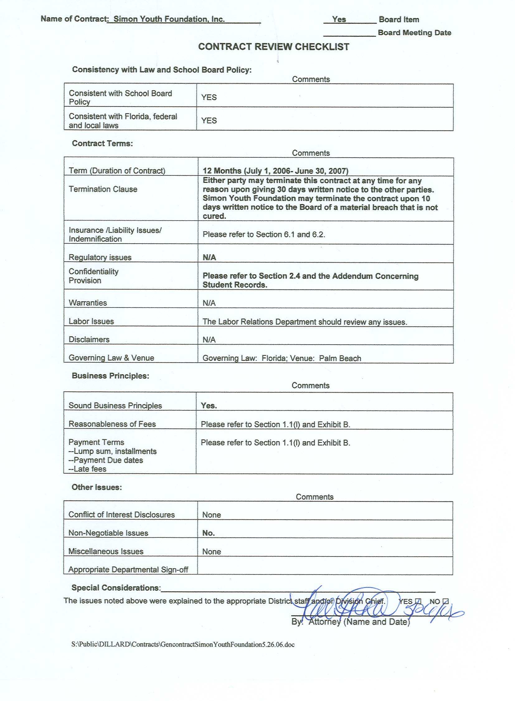Contract between

SCHOOL BOARD of Palm Beach County

and

PACE Center For Girls. Inc.

This Contract, dated July 1, 2006 is by and between The SCHOOL BOARD of Palm Beach County, Florida, hereinafter referred to as the "SCHOOL BOARD" and the Practical Academic Culture Education, PACE Center for Girls, Inc., hereinafter referred to as "PACE Center."

Whereas, the PACE Center is a not for profit corporation with main offices at 1225-D Military Trail, West Palm Beach, Florida 33415 and,

Whereas, the PACE Center is approved by the SCHOOL BOARD to conduct educational alternative programs of education, training, and related services for students identified and made eligible for such programs by 1003.53, F.S.; and,

Whereas, the SCHOOL BOARD has authority as provided by Section 1001.42, F.S., to engage in a cooperative relationship with corporations which have been formed for the purpose of providing an educational service to the District; and,

Whereas, the SCHOOL BOARD wishes to provide educational alternative programs and training for students who meet program criteria and believes that the PACE Center offers such a program, now therefore,

IT IS AGREED:

For and in consideration of the mutual covenants contained herein, the parties agree as follows:

- The term of this Contract shall be for educational services provided from July 1, 2006 through June 30, 2007. This Contract may be modified or amended only by mutual written consent of the parties. This Contract may be terminated by either party for any reason, including but not limited to insufficient educational funding, upon thirty (30) days written notice. Board may terminate this contract immediately for issues relating to health, safety and welfare of students.

- The parties shall not discriminate against any employee or participant in this program because of race, age, religion, color, gender, national origin, marital status, disability or sexual orientation as provided by law.

- This Contract shall be reviewed annually and may be amended by the written request of either party. Any proposed amendments or modifications shall be submitted by either party at least thirty (30) days prior to formal discussion or negotiation on the issue. Any amendments must be agreed to in writing by the authorized representative of each party.

- The SCHOOL BOARD shall reimburse the PACE Center ninety-four percent (94%) of FTE revenue earned by the SCHOOL BOARD through the Florida Education Finance Program (FEFP) for educational services provided to a maximum of sixty (60) middle and/or high school students. In the event of an audit citation resulting in a financial adjustment, the PACE Center or the SCHOOL BOARD will compensate the other party accordingly for under or overpayment within a reasonable period of time of notification. If adjustments in state revenue occur, they will be assigned to the PACE Center on a prorated basis. (Appendix A)

- The PACE Center shall provide a program of education, training and related services for up to sixth (60) middle and/or high school students.

STUDENT ELIGIBILITY, Rule 6A-6.05281 (1), FAC.

- The PACE Center shall provide high quality educational services to all students in the DJJ program approved by the SCHOOL BOARD that offer an integrated instructional curriculum for students that includes, but is not limited to, the following subjects: Language Arts, Math, Social Studies, Science, Life Skills, Employability skills and selected electives. The PACE Centers curriculum shall be challenging, provoke critical thinking, and incorporate survival skills, goal setting and achievement of socially acceptable behavior patterns approved by the SCHOOL BOARD.

- The PACE Center shall provide time and space for SCHOOL BOARD personnel to conduct psychological and educational testing for any student previously identified as an exceptional education (ESE) student and any student referred for ESE placement.

- The PACE Center shall collaborate with SCHOOL BOARD staff to implement Individual Educational Plans for any student identified as an exceptional education student. Individual Academic Improvement Plans (AIP) will be developed for all students and encompasses all quality assurance standards. The AIP will be forwarded by the PACE Center to the SCHOOL BOARD’s registrar’s attention within fifteen (15) days of enrollment or exit from the program. Effective dates and ending dates will be given on each AIP.

- The PACE Center shall furnish an appropriate education program for eligible regular and special needs students to include Limited English Proficient (LEP) students, students qualifying under Section 504 of the Rehabilitation Act of 1973/Title II of the American Disabilities Act of 1990, and students eligible for services pursuant to the IDEA.

- The PACE Center shall provide to students who are sixteen years of age or older and meet the eligibility requirements the opportunity to enroll in the GED Exit Option Model and will follow all state and district guidelines. The cost of the test shall not be the responsibility of the SCHOOL BOARD.

- The PACE Center shall provide a minimum of one Exceptional Student Education (ESE) certified teacher to develop, implement and determine mastery of the Individualized Educational Plans (IEP) goals for the exceptional educational students.

STUDENT RECORDS, Rule 6A-6.05281(2), FAC.

- The SCHOOL BOARD shall make available, upon request of the PACE Center, any and all educational records in its possession for PACE Center students including, but not limited to, academic assessment, psychosocial profiles, grade reports, attendance data, and cumulative records. The PACE Center shall comply fully with laws, policies, and rules guaranteeing the confidentiality of student educational records and access thereto.

- The PACE Center shall provide the SCHOOL DISTICT records and data on enrolled students so that SCHOOL BOARD staff can enter data into the TERMS system.

- The PACE Center shall provide an approved SCHOOL BOARD registration form for each students enrolled in its educational program. This form, reflecting parents/guardian consent, must be signed and dated prior to program enrollment each time a student enters an Alternative Education Program. A new form is required each school year.

- The PACE Center and the SCHOOL BOARD shall adhere to federal and state laws governing confidentiality of student information for any enrolled or previously enrolled student.

- The PACE Center shall permit review of the educational program and records, and confer with SCHOOL BOARD staff during regular business hours.

- The PACE Center shall provide open and frequent communication and planning through regularly scheduled meetings with SCHOOL BOARD staff regarding student behavior, unusual events, or obstacles incurred in meeting the mutually agreed upon goals.

- The PACE Center shall submit reports in a timely manner to the SCHOOL BOARD as required by the SCHOOL BOARD for its own use as well as those required by the Florida Department of Education.

- The PACE Center shall collaborate with SCHOOL BOARD staff to certify mastery of student performance standards for promotion or credit toward a high school diploma, in accordance with the SCHOOL BOARD’S approved Pupil Progression Plan.

- The PACE Center shall report attendance on a daily basis using the SCHOOL BOARD automated attendance scanner reports. Attendance reports must be delivered to the Alternative Education Department on a daily or weekly basis during the school year. (Appendix B)

- The PACE Center shall keep accurate records of student attendance sufficient for fiscal and FTE audits by following and using SCHOOL BOARD policies and procedures for truancy and attendance. As per Educational Programs for Youth in Department of Juvenile Justice Detention, Commitment, Day Treatment, or Early Delinquency Intervention Programs 6A-6.05281(8)(b)-4,a-e …”Student attendance shall be taken once per class period or during each course reported for FTE purposes. Time students spend participating in school activities such as field trips, performances, or receiving school-based services such as counseling may be counted as direct instructional time. Certain interruptions to the educational program, over which the teacher and student have no control, do not have to be deducted from the direct instruction time reported for FTE. These (interruptions) include: fire drills, lockdowns of the classroom or program for security purposes, bomb scares, court hearings and meetings students have with law enforcement personnel during school hours.”

- The SCHOOL BOARD shall provide student records for exiting students upon request from the receiving school/district.

- The SCHOOL BOARD staff shall enter and maintain data on TERMS for recording and transmitting records on enrolled students.

- The SCHOOL BOARD shall provide the PACE Center with notice of required reports and due dates within a reasonable lead-time for completion.

STUDENT ASSESSMENT, Rule 6A-6.05281(3), FAC.

- The PACE Center shall collaborate with SCHOOL BOARD staff to provide appropriate grade placement for each student consistent with the SCHOOL BOARD’S approved Pupil Progression Plan.

- The PACE Center shall provide time and staff for students to participate as appropriate in District and State testing programs.

- The PACE Center shall adhere to the guidelines and criteria in the Palm Beach County Pupil Progression Plan, and follow the State of Florida’s curriculum frameworks, performance standards, and graduation requirements, as well as applicable Federal and State Laws and the State Board of Education Rules.

- The PACE Center shall administer appropriate testing as determined by the SCHOOL BOARD for entry and exit levels and placement within the educational program. The PACE Center shall complete assessments as per the Educational Quality Assurance Standards, the Department of Education Rule Educational Programs for Youth in Department of Juvenile Justice Detention, Commitment, Day Treatment, or Early Delinquency Intervention Programs 6A-6.05281 and SCHOOL BOARD requirements for all students upon entry and exit. Test results are to be forwarded to the SCHOOL BOARD registrar. The PACE Center will use the SCHOOL BOARD’s and DOE’s approved, age appropriate, assessment instruments in Appendix D. The SCHOOL BOARD will notify the PACE Center if any change in instruments occurs.

- The SCHOOL BOARD shall provide materials and coordinate testing for any state required student achievement tests.

TRANSITION SERVICES, Rule 6A-6.05281(5)

- The PACE Center shall collaborate with SCHOOL BOARD staff to provide transition services to ensure a smooth transition when the students return to their respective communities and schools or placed on a job.

- The PACE Center shall provide transition plans which contain academic re-entry goals, career and employment goals, and provide input regarding the recommended educational placement of the student.

INSTRUCTIONAL PROGRAM AND ACADEMIC EXPECTATION, Rule 6A-6.05281(6)

- The PACE Center shall provide an education program from July 1, 2006 through June 30, 2007. Students shall be provided instruction for a minimum of 300 minutes each school day. P.A.C.E will provide services year round for 250 days, 230 of which will be academic school days in compliance with the local school board 12-month calendar. Pace shall not allow the removal of students from class during academic instruction. The PACE Center shall provide the SCHOOL BOARD with a school calendar to be approved by the school board. (Appendix C)

- The PACE Center shall provide reasonable attempts at instruction for all students through the entire continuum of disciplinary consequences by using the district approved discipline matrix and district approved student discipline referral form. (Appendix D)

- The PACE Center shall collaborate with SCHOOL BOARD staff to provide a library/media center as needed.

- The PACE Center shall provide materials and supplies for students including appropriate educational instructional software. Software mandated by the SCHOOL BOARD will be provided at no cost to PACE.

- The PACE Center shall provide for a continuous progress, open-entry and open-exit, pursuant to all applicable State Statutes.

- The PACE Center shall provide a secular education to public school students and ensure that public funds will in no way be used to advance or promote the teaching of religion.

- The PACE Center Director shall attend or send a designee to the monthly School Advisory Meetings.

- The SCHOOL BOARD shall provide the necessary resource personnel (including ESE & ESOL) to ensure programmatic integrity as well as compliance with state, federal and local laws.

- The SCHOOL BOARD shall coordinate planning for and provide textbooks and testing materials. The PACE Center will reimburse the SCHOOL BOARD for any lost or damaged non-consumable instructional materials in accordance with SCHOOL BOARD Policy.

QUALIFICATION AND PROCEDURES FOR SELECTION OF INSTRUCTIONAL STAFF, Rule 6A-6.05281 (7), FAC.

- The PACE Center shall provide evidence of a satisfactory background check and fingerprinting for each instructional staff member. The PACE Center will pay the SCHOOL BOARD for these services if rendered.

- As authorized by the SCHOOL BOARD, The PACE Center shall hire only staff/teachers holding teacher certificates to cover appropriately the required courses. Specifically, the academic instructional personnel must have professional or temporary State of Florida teaching certification or Statement of Eligibility. Vocational instructors must possess documented experiences and expert knowledge and/or skill in the field(s) they are teaching. (No Child Left Behind Act of 2001-H.R.1/P.L. 107-110—the Reauthorization of ESEA):

Teacher shall be certified and Highly qualified by end of 2005-2006-school year.

Paraprofessionals: Any hired after January 8, 2002 must have
- Completed two (2) years of college;
- Obtained and associate’s or higher degree;
- Meet requirements of a state or local academic assessment.
Existing staff shall have four (4) years from January 8, 2002 to meet the above requirements.
The PACE Center is liable for all FTE disallowed due to the hiring of ineligible teachers. This is grounds for cancellation of the contract. The PACE Center’s teachers should be individuals who are experts in their respective fields as addressed by State Board Rules Noncertificated Instructional Personnel 6A-1.0502 and Definition of Qualified Instructional Personnel 6A-1.0503.

- The PACE Center shall employ properly certified substitute teachers for permanent instruction personnel who are temporarily absent due to illness or personal reasons.

- The PACE Center shall provide the SCHOOL BOARD’S Alternative Education Department with names and social security numbers of potential instructional staff for screening and clearance by the District prior to hiring.

- The PACE Center shall provide the SCHOOL BOARD with the names and temporary certificates of teachers who participate in the District’s Professional Education Competence Program. The PACE Center shall furnish the Support Staff Agreement form located in Appendix E to each teacher on staff without a permanent Florida teaching certificate. Appendix E is to be forwarded to the Alternative Education Secondary Principal in the District’s Alternative Education Department. The PACE Center will insure that the form is completed and submitted within five (5) working days of employment. If the PACE Center has no eligible staff to serve as mentors, the Alternative Education Secondary Principal will recommend a qualified mentor and other professional educators as necessary, based on availability of qualified staff. The PACE Center will absorb the additional costs incurred by the District to meet the requirements of the ESP for beginning teachers. These costs may be deducted from the PACE Center invoice at a rate of $35.00 an hour or time and one-half, if services are beyond the workday.

- The PACE Center shall provide a pupil/instructional staff ratio of 17:1 to meet the needs of students.

- The PACE Center shall provide Alternative Education Department with documentation of all educationally related in-service training for teachers.

- The PACE Center shall provide in-service training for teachers to keep them abreast of the best teaching strategies for at-risk youth.

- The PACE Center shall notify the Alternative Education Department when a teacher is being released and/or replaced with in a twenty-four (24) hour period.

- The PACE Center shall provide substitute teachers as needed to ensure continuity of the educational program for students.

- The PACE Center shall include the SCHOOL BOARD staff on recruitment and/or selection of instructional staff.

- The SCHOOL BOARD shall allow the PACE Center teachers to participate in SCHOOL BOARD staff development activities as space permits.

FUNDING, Rule 6A-6.05281(8), FAC.

- The SCHOOL BOARD will issue monthly payments for each FTE survey period as legislative mandated and upon receipt of an invoice from PACE Center.

- The PACE Center’s payments shall be based upon an equal monthly distribution generated by full time equivalent students enrolled in the PACE Center’s educational program, not to exceed ninety (90) FTE students. As required by chapter 1000.01 F.S and chapter 1010.21 F.S. the rate of payment shall be equal to 94% of the FTE revenue generated through the Florida Education Finance Program (FEFP) and shall include the Categorical Funds for instructional materials, instructional staff training, instructional technology, and science lab materials.

- One hundred percent (100%) of the funds paid by the SCHOOL BOARD must be used to support the PACE Center’s educational program. Eighty percent (80%) of the funds paid by the SCHOOL BOARD must be used for Direct Classroom Expenses limited to instructional personnel (with student contact) salaries and benefits, classroom materials and supplies, and classroom equipment.

- If, at any time during the term of this CONTRACT, the STATE Department of Education changes the SCHOOL BOARD formula allocation of funds, said increase or decrease shall be passed along to the PACE Center on a pro rata basis.

- In the event the PACE Center violates any Florida law, State Board of Education rule, School Board policy, and/or other covenant set forth herein, and said violation results in a loss of funding to the BOARD, The PACE Center shall reimburse the SCHOOL BOARD for the full amount of the loss. This provision shall remain in force, even if the Contract is terminated, for a period of three (3) years or until all State audits are conducted, whichever occurs first.

- The PACE Center’s full-time equivalent membership shall be counted during the official FTE survey periods determined by the State Department of Education. Failure by the PACE Center to meet targeted projections during these established weeks shall result in a reduction of funds and an appropriate adjustment in monthly payments.

- Membership – A student at the PACE Center is in membership when he/she is officially assigned (not withdrawn) to a course or program by the SCHOOL BOARD. To be reported for funding, each student must be enrolled and scheduled appropriately in the state automated data system. All course identification information must be accurate such as state approved course number, section number, period number, days per week and class minutes.

- The PACE Center shall provide classroom space, furniture, equipment, and supplies. The PACE Center shall make modifications and repairs to the facilities as cited in the SCHOOL BOARD Comprehensive Safety Inspection Report in a timely manner in order to comply with 1013.20 F.S., State Requirements for Educational Facilities.

- The SCHOOL BOARD shall establish timelines and required data elements to ensure timely and accurate reporting of FTE counts.

- The SCHOOL BOARD shall provide access to lunch for free and/or reduced lunch eligible students. Non eligible students may purchase meals at the standard SCHOOL BOARD rate. The PACE Center shall transport meals from the SCHOOL BOARD identified public school to the PACE Center at a time established by the SCHOOL BOARD.

- The SCHOOL BOARD shall provide transportation.

CONTRACTS WITH PRIVATE PROVIDERS, Rule 6A-6.05281(9), FAC.

- The SCHOOL BOARD shall review and consider the PACE Center’s past performance history, including the results of the Quality Assurance Review. Unsatisfactory findings shall result in the development of a corrective action plan to be submitted to the SCHOOL BOARD within 30 days of the review. The Superintendent’s designee shall monitor the plan. Failure to comply with the corrections within six (6) months will be considered a default and can lead to termination of the Contract. In the event the Quality Assurance Review cannot be scheduled within 60 days, the District Contract Manager shall select and send a team to verify that the PACE Center has met the minimum standards. Costs, including staff time, incurred by District for noncompliance shall be deducted from payments due from the most current invoice. If the PACE Center determined not to have met the minimum standards, the School may exercise the ten (10) termination clause in this contract.

- The Superintendent shall give the PACE Center ten (10) calendar days prior notice by United States Postal Service certified mail, return receipt request. The PACE Center shall cooperate with SCHOOL BOARD’S employees, appointees, and/or agents as they attend to their assigned task. Upon development of a final report, the PACE Center shall be given twenty (20) calendar days to react and draft a response which shall be included in the report to the SCHOOL BOARD.

- The PACE Center shall provide a financial accounting of all expenditures toward the educational component of the program on a quarterly basis. The accounting report shall be in accordance with forms provided by the Superintendent’s designee and shall be delivered to the Superintendent’s designee within ten days after the close of each quarter. (Appendix F)

INTERVENTIONS AND SANCTIONS, Rule 6A-6.05281(10), FAC.

- PACE Center shall form and maintain an advisory board with broad based representation.

- PACE Center shall collaborate with SCHOOL BOARD staff to develop and implement an improvement plan as may be required by the SCHOOL BOARD.

COORDINATION, Rule 6A-6.05281 (11)

- The PACE Center shall provide a dedicated telephone line and telephone facsimile, at no cost to the SCHOOL BOARD, for official school-related business. In addition, the PACE Center shall provide telephone lines, at no cost to the SCHOOL BOARD, for instructional telecommunications purpose at mutually agreed upon locations.

- THE BOARD recognizes its liability for certain tortious acts of its agents, officers, and employees to the extent and limit provided in 768.28, Florida Statutes, the State of Florida’s partial waiver of sovereign immunity. Provided, however, this provision shall not be construed as a waiver of any right of defense that THE BOARD may possess and reserves all such rights against any and all claims that may brought under this Contract.

- The PACE Center hereby represents and warrants that it is in compliance with the Civil Rights Act of 1964, IDEA, Title IX of the education Amendment of 1974 and Section 504 of the Rehabilitation Act of 1973 and will at all times comply with local and State standards for health and safety of students.

- The PACE Center shall provide the Director of Alternative Education a copy of the contract between the Department of Juvenile Justice (DJJ) and the PACE Center. This will be used as a basis to establish and maintain eligibility for funding as a Juvenile Justice provider and validate the fundable students in this contract. The SCHOOL BOARD shall provide the PACE Center with a copy of the cooperative agreement between the Department of Juvenile Justice (DJJ) and the SCHOOL BOARD.

- The PACE Center shall be liable, and agrees to be liable for, and shall indemnify, defend and hold the SCHOOL BOARD harmless for all claims, suits judgments, or damages, including court costs and attorney fees, arising out of or in the course of its provision of the services called for in this Contract, and shall secure and maintain in force liability insurance to provide such indemnification, to the full extent of the SCHOOL BOARDS liability under law.

The PACE Center will maintain the following insurance policies during the term of this contract:

General Liability Insurance including contractual liability coverage with limits of not less than $1,000,000.00 per occurrence combined single limit for bodily injury and property damage. The SCHOOL BOARD of Palm Beach County must be named an additional insured on the general liability policy.

Statutory Workers’ Compensation and Employers’ Liability Insurance with a limit of not less than $100,000.00 per occurrence.

Automobile Liability Insurance with limits of not less than $1,000,000.00 per occurrence combined single limit for bodily injury and property damage.

The PACE Center will provide the SCHOOL BOARD with current certificates of insurance as evidence that the required insurance coverage including a provision for not less than 30 days advance written notice of cancellation or material change of the insurance.

The staff of the SCHOOL BOARD will be permitted to review the program provided by the PACE Center and confer with its staff during school hours and at other reasonable times. Further, the SCHOOL BOARD and the PACE Center agree to abide by all procedures and guidelines developed and mutually agreed by both parties regarding the implementation of this Contract.

The PACE Center will notify the SCHOOL BOARD of the withdrawal of any student within twenty-four (24) hours of the withdrawal.

The PACE Center will submit, upon completion of this Contract, an independent financial and compliance audit complete with management letter in accordance with standards promulgated by the United States General Accounting Office. This audit should be submitted to the SCHOOL BOARD within 120 days of the provider’s fiscal year end. In the event that the provider’s fiscal year end occurs prior to the completion of the term of this Contract, provider will supply the audit and accompanying management letter for each of the provider’s fiscal years occurring during the term of this Contract. Each such audit and management letter will be provided within 120 days of the provider’s fiscal year end. Audit findings contained in the management letter shall be resolved by provider in a timely manner.

In the event of litigation between the parties to this Agreement, venue shall lie in Palm Beach County, Florida, and the prevailing party shall be entitled to reasonable attorney's fees and costs. The PACE Center assures the SCHOOL BOARD of Palm Beach County, Florida, that it does not discriminate on the basis of race, sex, marital status, national origin, religion, handicap, or age, in the operation of its business or provision of services. This Agreement may not be assigned without the written consent of both parties.

IN WITNESS WHEREOF, the parties hereto have hereunto set their hands and seals the day and year first hereinabove set forth,

PACE Center For Girls, Inc.

By: ___________________________
Sharon Cohen, Executive Director

Date: __________________________

By: ___________________________
William Kramer, Board President

Date: __________________________

“Reviewed and Approved As To Legal Form and Sufficiency”

By: ____________________________
Associate Counsel

Date:__________________________
The School Board of Palm Beach County

By: __________________________
Thomas Lynch, Chairperson

Date: _________________________

By: ___________________________
Arthur C. Johnson, Ph.D., Superintendent

Date: __________________________

“Reviewed and Approved As To Legal Form and Sufficiency”

By:____________________________
Associate Counsel

Date:__________________________

Appendix A
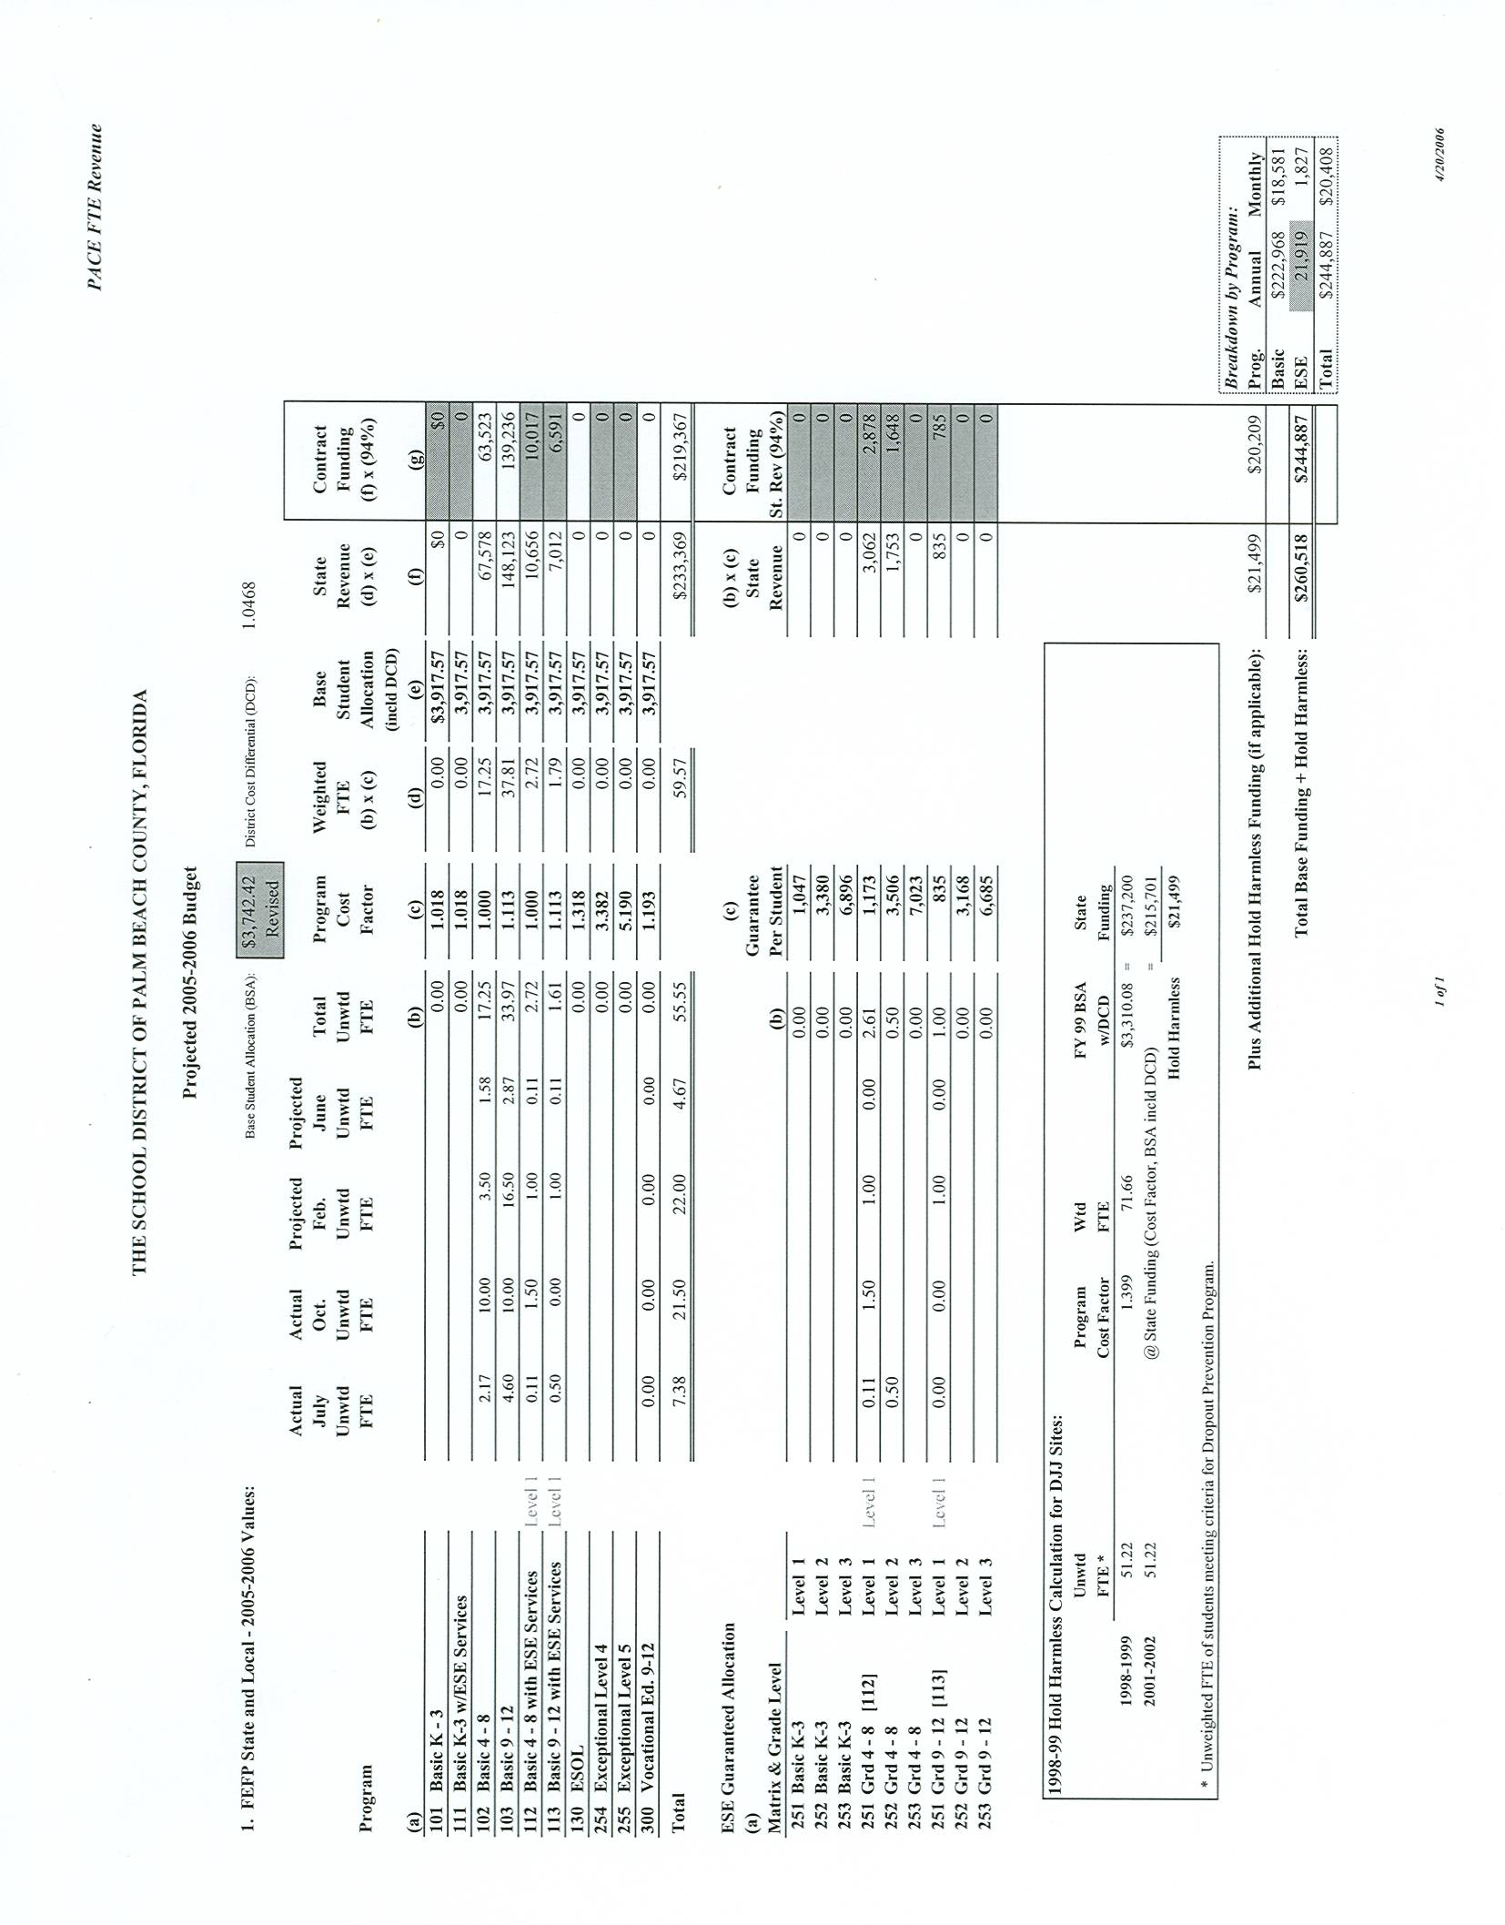

Appendix B
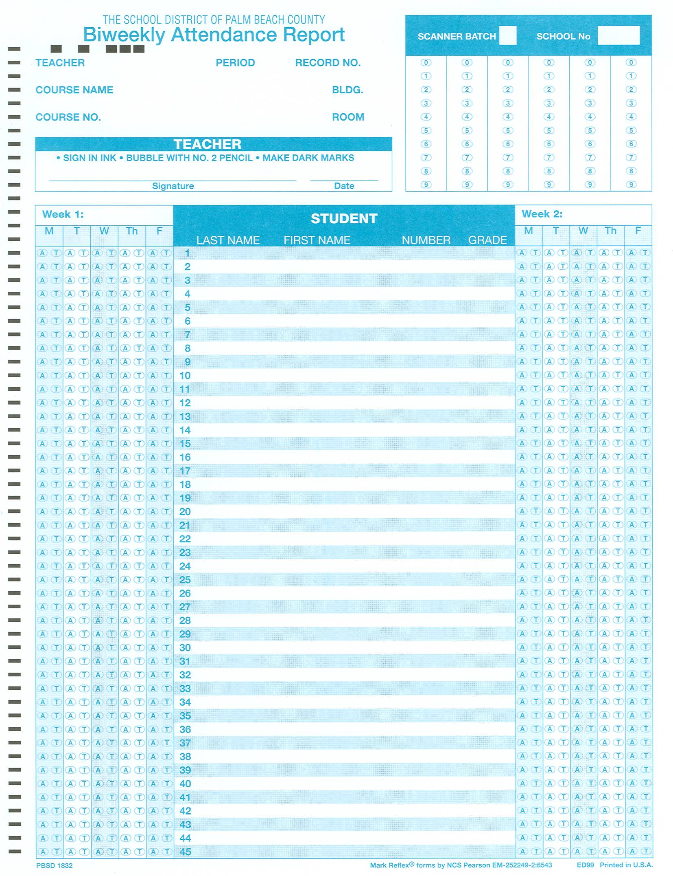

Appendix C
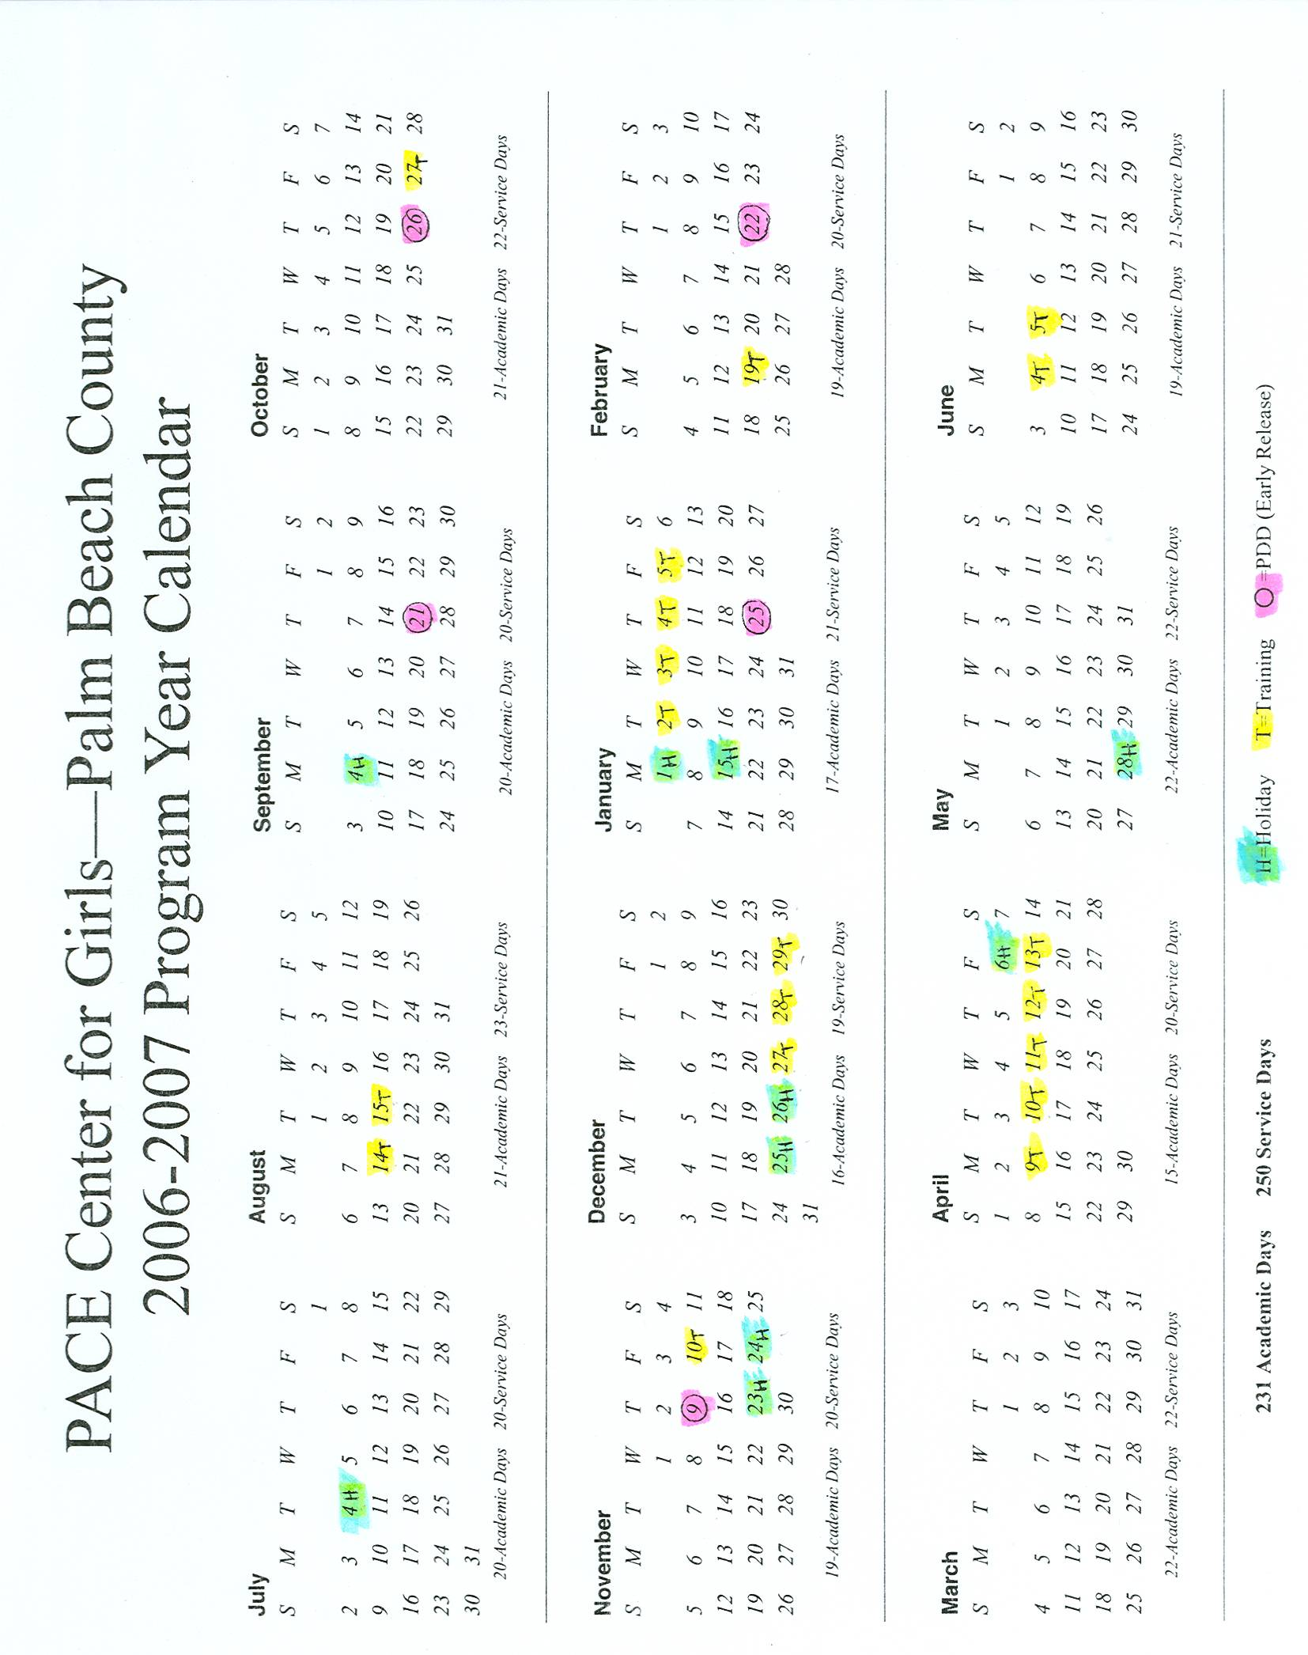

Appendix D
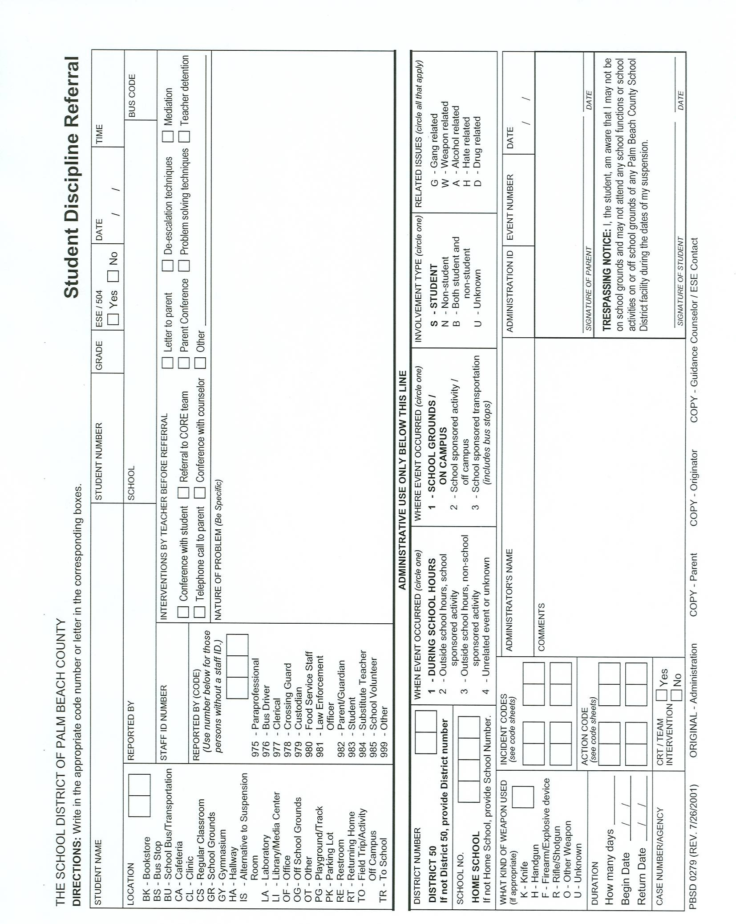

Appendix E
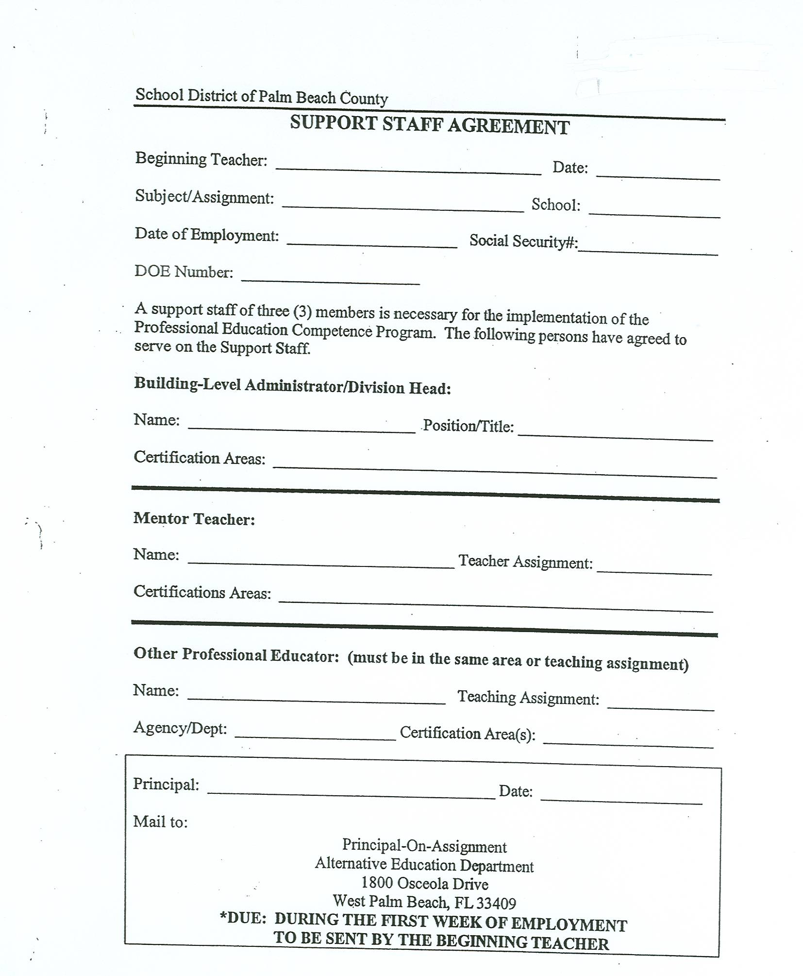

Appendix F


